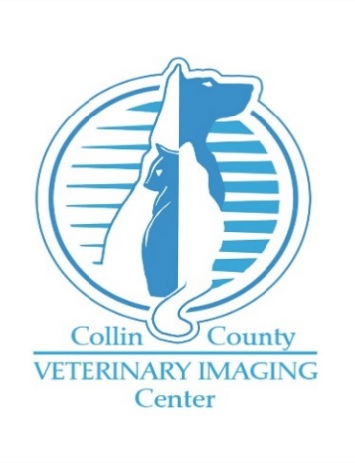

Clinic Name: ___________________________________________________

Referring Veterinarian: ___________________________________________

Date: _____________________ Clinic phone: _________________________
Email address: __________________________________________________

IMAGING REQUEST & REFERRAL FORM Date:________________________________________
Owner Name: First_________________________ Last__________________________________________
Phone Number: ____________________________Secondary Phone Number_________________________
Patient Name: ________________________ Age: ______________ Breed: __________________________
Wt. _________lb./kg. (circle one) Sex: Neutered Male / Spayed Female / Male / Female (circle one)

Patient History:

Ultrasound: (circle one) Abdominal / Echocardiography (heart only)
Do you recommend sedation based on patient history? (circle one) Yes / No / Not Sure
Computed Tomography: (circle one) Head / Abdomen / Pelvis / Thorax / Spine and neck / Extremities
□ YES, I consent to CT-SCAN Contrast Media Administration (Additional Charges may apply)
For a complete assessment, please send any recently performed imaging including radiographs with the patient regardless of desire for radiographic consultation. For CT imaging with contrast please include recent (within 6 months) blood work including renal profile. Preliminary ultrasound results may be available the same day and radiology consultation for both ultrasound and CT are typically available within 24-48 hours.
Collin County Veterinary Imaging Center / 5353 Independence Pkwy. Ste. 100 / Frisco, TX 75035
P: (469)795-9142 F: (469)795-9143 / Email: info@ccvic.us / Website: www.ccvic.us

